Guidance on using the DOPS Excel spreadsheet

Please click on ‘CLICK HERE TO VIEW OUR UP TO DATE DOPS LIST’, and then click on ‘Download’ (top, right hand side) to allow you manipulate the table on your computer.
There are already 200+ DOPS in the system. A simple way to refine your search to identify the DOPS of interest is via dropdown menus. Each Column has a dropdown menu – these can be accessed via the arrows on the right-hand side of each cell in Row 3.
In some versions of Excel you might have to select the ‘Filter’ option to enable you to see all the options by which you can filter; in other versions (Figure 1) all the options will automatically be displayed. The dropdown menu is usually set to show all options via ‘Select All’. You can refine your choice by:
- Clicking on the tick in the ‘Select All’ – this will remove the ticks from all the options in that dropdown menu
- Then click on the specific category in which you are interested. For example, if you want to access all DOPS relating to rodents, tick the ‘Rodent’ box in the Column A dropdown menu, and then click ‘OK’.
You can further refine your selection: to access all rat DOPS, click on the ‘Select All’ tick in the Column B dropdown, and then click on all the categories which mention ‘rat’ followed by ‘OK’. Some DOPS will be for rat only, others relate to rat and other rodents. If you only choose ‘Rat’ from the dropdown menu, you will only access DOPS written solely for that species; those DOPS covering, say, rat and mouse will not appear.
Once you have identified the DOPS of interest, you might need to reset all the dropdown menus so that all options are selected; obviously, if ‘Rodent’ is chosen in Column A you won’t be able to see, for example, any primate-related DOPS. Again, the mechanism for doing this might be version dependent. In some, ‘Select All’ by clicking on that box followed by ‘OK’ in the dropdown. In others, click the downward facing arrow at the top of the column on which you have set filter and then choose the option ‘Clear filter’ from the category you have chosen to search through (e.g. species, skill category etc – Figure 2). Please note you may have to perform this action multiple times on different columns if you have refined your search requirements extensively.
In most cases, it makes sense to refine your search by going stepwise along the Columns from left to right, but there are other options. For example:
- If you want to identify all DOPS for horse, click on ‘Select All’ in Column B, then choose ‘Horse’ from the dropdown menu, followed by ‘OK’.
- If you want to find all DOPS related to induction and maintenance of anaesthesia (irrespective of species), choose that option (followed by ‘OK’) in the Column D dropdown.
Again, if you cannot find a DOPS that you would expect to be there, it is possible that one of the filtering options you have chosen precludes you from accessing it – reset all Columns to ‘Select All’.

Figure 1
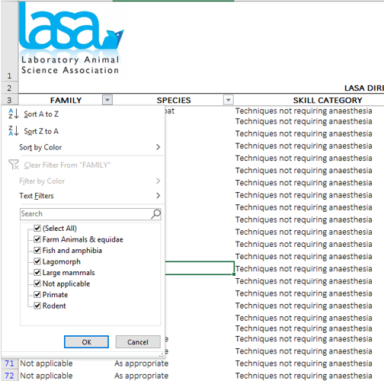

Figure 2
